INTRODUCTION

Project: “Sports Hall Booking System”
The Sports Hall Booking System is a comprehensive web-based platform designed to simplify and automate the process of reserving sports halls and indoor sports facilities within educational institutions, sports complexes, and recreational organizations. It provides a centralized system for managing bookings, scheduling, user registrations, and facility availability through a user-friendly interface. The system enables students, staff, members, and administrators to efficiently book sports halls for various activities such as badminton, basketball, volleyball, table tennis, fitness sessions, and other indoor sports.
The Sports Hall Booking System plays a significant role in modern sports facility management by offering a centralized platform for handling reservations and resource allocation. One of its primary functions is to allow users to check real-time availability of sports halls and reserve their preferred time slots online. This booking process eliminates manual paperwork, prevents scheduling conflicts, and ensures fair and transparent allocation of sports facilities. The system also maintains detailed records of all bookings, including user information, booking dates, time slots, facility details, booking status, and payment information (if applicable).
The system supports the complete booking lifecycle—from user registration and booking requests to booking confirmation, modification, cancellation, and completion. Administrators can manage sports halls, define operating hours, approve or reject booking requests when necessary, and monitor overall facility utilization. This centralized management helps improve scheduling efficiency and ensures optimal use of available sports facilities.
In addition, the Sports Hall Booking System includes features such as automated notifications and reminder services. The system sends confirmation messages, booking reminders, cancellation alerts, and schedule updates through email or SMS notifications. It also prevents double bookings by automatically checking hall availability before confirming reservations. These features enhance user convenience, improve communication, and ensure smooth operation of the booking process.
The system maintains a complete database of sports halls, users, booking history, maintenance schedules, and facility availability. It provides administrators with real-time reports and analytics to monitor booking trends, peak usage periods, facility occupancy, and user activity. These insights assist management in planning maintenance, improving resource utilization, and making informed decisions regarding sports facility management.
The benefits of the Sports Hall Booking System are numerous and significant. It improves operational efficiency by automating booking and scheduling processes while reducing administrative workload. It enhances user satisfaction by providing a quick, convenient, and transparent reservation system that can be accessed anytime and from anywhere. The system minimizes scheduling conflicts, maximizes facility utilization, and ensures accurate record management. Furthermore, it supports better planning, accountability, and data-driven decision-making through real-time reports and analytics. Overall, the Sports Hall Booking System promotes efficient management of sports facilities, encourages greater participation in sports activities, and contributes to a well-organized and digitally managed sports environment.

IDEATION PHASE

PROBLEM STATEMENT:
The Sports Hall Booking System will streamline the reservation, scheduling, and management of sports halls within an organization or educational institution. Users will be able to view available sports facilities, book preferred time slots, and track the status of their reservations through an intuitive ServiceNow portal, while administrators can manage the complete booking lifecycle, from request submission to approval, modification, cancellation, and completion. The system will automate booking approvals, prevent scheduling conflicts, maintain accurate booking records, and generate real-time reports on hall utilization and user activity. Automated notifications and reminders will be sent for booking confirmations, cancellations, and upcoming reservations, ensuring smooth communication and efficient facility management. By centralizing the sports hall booking process, the platform will improve operational efficiency, maximize facility utilization, reduce manual administrative work, and support informed decision-making through real-time analytics and reporting.

What are challenges faced without “Sports Hall Booking System”:

- Difficulty in managing sports hall reservations efficiently.
- Increased chances of double bookings and scheduling conflicts.
- No automated notifications for booking confirmations, cancellations, or reminders.
- Poor visibility into sports hall availability, booking status, and facility utilization.
- Challenges in generating reports for booking history, hall usage, and administrative
planning.

OBJECTIVE:
Automate the reservation, scheduling, and management of sports halls by providing real-time updates on hall availability, booking status, and time slot allocation. Enable users to book sports facilities through a self-service portal, notify administrators and users about booking confirmations, cancellations, and schedule changes, and prevent double bookings through automated validation. Generate real-time reports and analytics on hall utilization, booking trends, and user activity to optimize facility management, improve resource utilization, and support informed decision-making.

REQUIREMENT ANALYSIS

SOLUTION REQUIREMENT:

TEAM ID | SWTID-2026-4300
PROJECT NAME | “Sports Hall Booking System”

Functional Requirements:
Following are the functional requirements.

FR NO | Functional Requirement | Sub Requirement
FR-1 | Business Objectives | Optimize court utilization, eliminate double-bookings, and track digital revenues. Business Objectives
FR-2 | Functional Scope | Provide a live scheduling matrix, booking wizard, and equipment rental options.
FR-3 | Stakeholder Mapping | Map features for Players (booking), Staff (check-ins), and Admins (pricing/rules)
FR-4 | Execution Roadmap)l | Define milestones: Phase 1 (Tables), Phase 2 (Workflows), and Phase 3 (Alerts/Testing)

Non-Functional Requirements:
Following are the functional requirements.

FR NO. | Non-Functional Requirement | Description
NFR-1 | Data Architecture | Relational schema connecting users, court inventory, time slots, and payments.
NFR-2 | Logics | Enforce hourly reservation blocks and fixed booking state progressions.
NFR-3 | Business Rules | Require 24-hour advance cancellation for refunds; cap active bookings at 3 per user.
NFR-4 | Interface Design | Clean dashboard with color-coded slots (Green: Open, Red: Booked, Amber: Maintenance).
NFR-5 | Navigation Flow | Direct 4-step user path: Select Sport → Choose Slot → Add Extras → Checkout.
NFR-6 | Data Handling | Prevent double-bookings with optimistic locking; archive historical records after 1 year.

Data Flow Diagram:
A Data Flow Diagram (DFD) is a simple graphical tool used to show how data moves through a system. It illustrates the input, processing, storage, and output of data using symbols like arrows, circles, and rectangles. In the Asset Management Portal, a DFD helps visualize how asset requests, approvals, assignments, and tracking are handled between users, the system, and databases.

Uses:
- Visualizes system processes and how data moves between them.
- Helps in understanding system structure clearly and quickly.
- Aids in system design and development by showing data input, processing, and output.

Technology Stack:
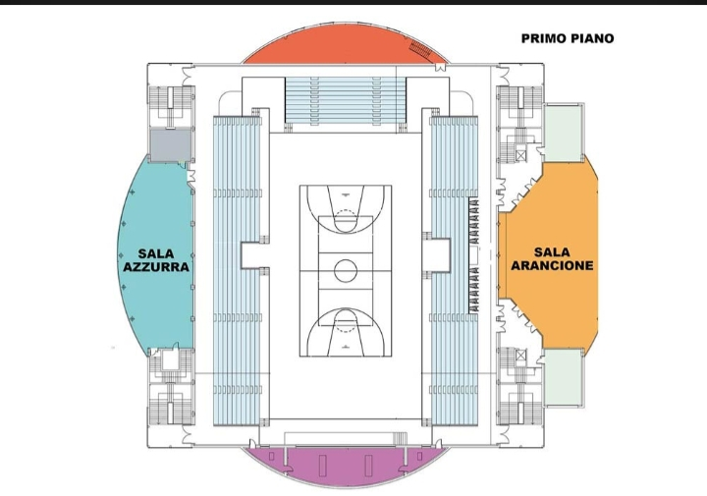

Architecture of ServiceNow

- Users access the Sports Hall Booking System through the ServiceNow Service Portal to submit booking requests.
- Booking requests are created and stored in the Sports Hall Booking Table within the ServiceNow database.
- Business Rules, Flow Designer, and Approval Workflows validate hall availability and process booking requests automatically.
- Approved bookings are recorded in the booking database, while rejected or cancelled requests are updated accordingly.
- The system sends automated email and notification alerts for booking confirmations, approvals, cancellations, reminders, and schedule updates.
- Administrators manage sports halls, available time slots, booking schedules, and user requests through the ServiceNow platform.
- Reports and Dashboards generate real-time insights on hall utilization, booking history, peak usage hours, and facility availability to support effective decision-making.

Project Design:

Proposed Solution:
Project team shall fill the following information in the proposed solution template

S. No | Parameter | Description
1 | Problem Statement (Problem to be Solved) | Sports hall booking is often done manually, causing double bookings, scheduling conflicts, and difficulty in tracking reservations. Users also face delays in checking hall availability.
2 | Idea / Solution Description | The proposed solution is a Sports Hall Booking System, a web-based platform that allows users to view available sports halls, book slots online, manage reservations, and receive booking confirmations
3 | Novelty / Uniqueness | The system provides real-time hall availability, instant online booking, automated notifications, and an easy-to-use interface for both users and administrators.
4 | Social Impact / Customer Satisfaction | The system saves time, reduces booking conflicts, improves transparency, and provides a convenient booking experience for students, staff, and sports enthusiasts.
5 | Business Model (Revenue Model) | The Sports Hall Booking System follows a Software-as-a-Service (SaaS) model. Revenue can be generated through subscription fees, membership plans, booking charges, or premium features.

“Sports Hall Booking System”

What is a Sports Hall Booking System?
A Sports Hall Booking System is a ServiceNow-based application that allows users to check hall availability, book sports facilities, and manage reservations online. It automates the booking process, reduces scheduling conflicts, and ensures efficient utilization of sports halls.

TYPES:

- Indoor Sports Halls – Basketball, volleyball, badminton, and table tennis courts.
- Outdoor Sports Grounds – Football, cricket, tennis, and athletics grounds.
- Multi-Purpose Halls – Facilities used for sports events, fitness activities, and tournaments.
- Training & Fitness Areas – Gymnasiums, yoga rooms, and fitness centers available for booking.

MILESTONE 1: Requirement Analysis & Planning

Activity 1: Business Objectives

PURPOSE:
- To identify the business goals of the Sports Hall Booking System.
- To simplify the sports hall reservation process through an online platform.
- To improve the utilization of sports facilities by avoiding scheduling conflicts.
- To provide a secure and transparent booking approval process.

USE:
- Enables users to reserve sports halls online.
- Reduces manual paperwork and booking errors.
- Supports efficient management of booking requests.
- Improves operational efficiency and user satisfaction.
- Provides accurate booking records for reporting and monitoring.

Activity 2: Functional Scope

PURPOSE:
- To define the core features and system functionalities.
- To establish the boundaries of the Sports Hall Booking System.
- To ensure all user requirements are addressed during development.

USE:
- Allows users to view available sports halls.
- Enables users to submit booking requests.
- Supports booking approval and rejection by administrators.
- Maintains booking history and current booking status.
- Generates reports and dashboards for booking analysis.

Activity 3: Stakeholder Mapping

PURPOSE:
- To identify all stakeholders involved in the booking process.
- To define user roles and responsibilities.
- To ensure smooth communication and workflow management.

USE:
- Students/Employees: Submit and manage booking requests.
- Sports Hall Manager: Reviews and approves or rejects bookings.
- System Administrator: Manages users, halls, permissions, and system configuration.
- Management: Monitors booking reports and hall utilization.

Activity 4: Execution Roadmap

PURPOSE:
- To create a structured implementation plan for the project.
- To organize development activities into manageable phases.
- To ensure timely completion of the Sports Hall Booking System.

USE:
- Phase 1: Requirement Analysis & Planning
- Phase 2: Database Design and Table Creation
- Phase 3: Forms, UI Actions, and Business Rules
- Phase 4: Workflow, Flow Designer, and Notifications
- Phase 5: Service Portal Development
- Phase 6: Testing, Reports, Dashboard, and Deployment

MILESTON 2: Backend Development & Configuration Data Architecture:

Activity 1: Creation of Table
- Navigate to: System Definition > Tables.
- Click New to create a new table.
- Fill in Table Information:
- Name: u_sports_hall_bookings
- Label: Sports Hall Bookings
- Click Submit to create the table.
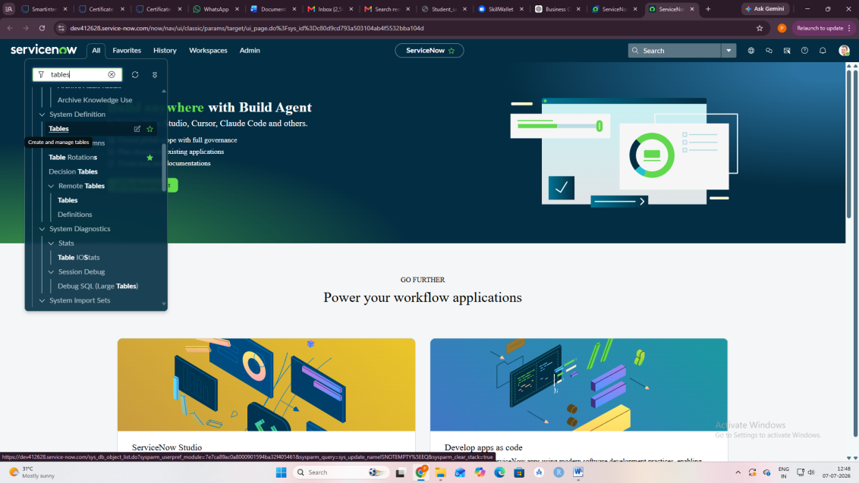

Activity 2: Creation of fields
- Open ServiceNow.
- In the Application Navigator, search for Tables.
- Go to System Definition → Tables.
- Open the Sports Hall Booking table.
- Scroll down to the Columns section.
- Click New.
- Enter the Field Label and select the Type.
- Click Submit or Save.

Repeat the same steps to

create all the required fields.

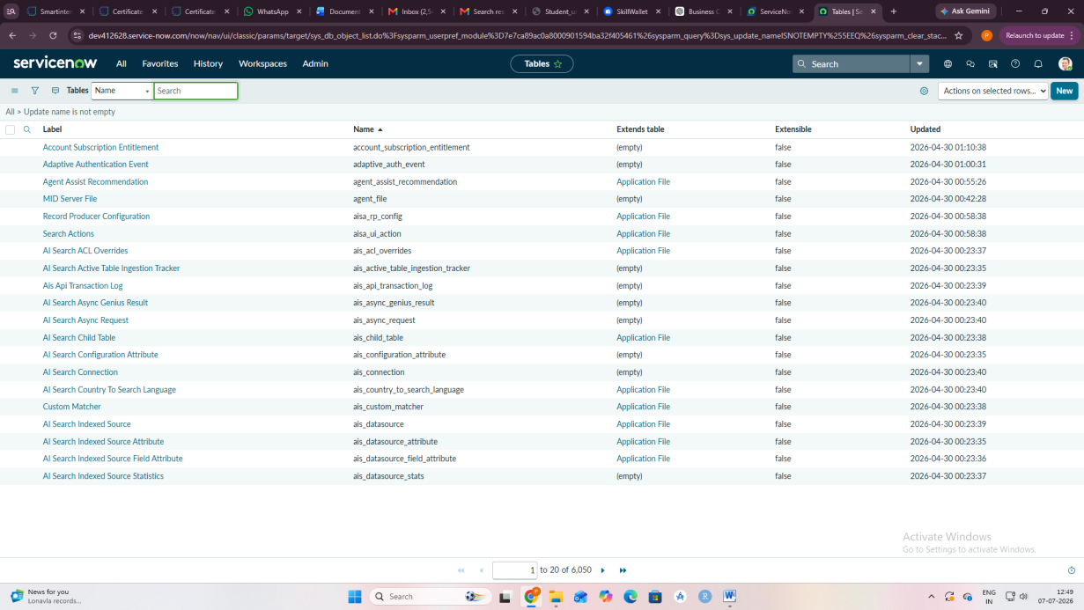

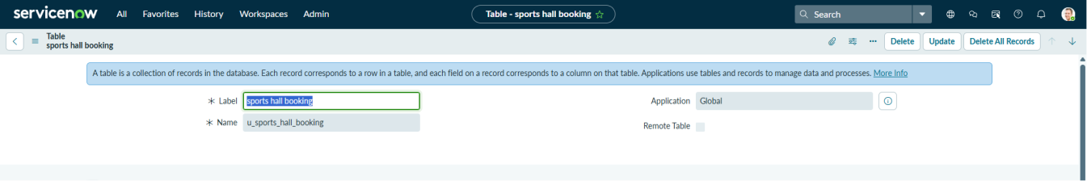

Logics:

Creation & Implementation of Scheduled Jobs Script

Activity 1. Navigation of Scheduled Jobs
- Navigate to All Menu
- Search for Scheduled Jobs
- Under System Definition, we have Scheduled Jobs
- Open the Table and Click on New button to create new Schedules
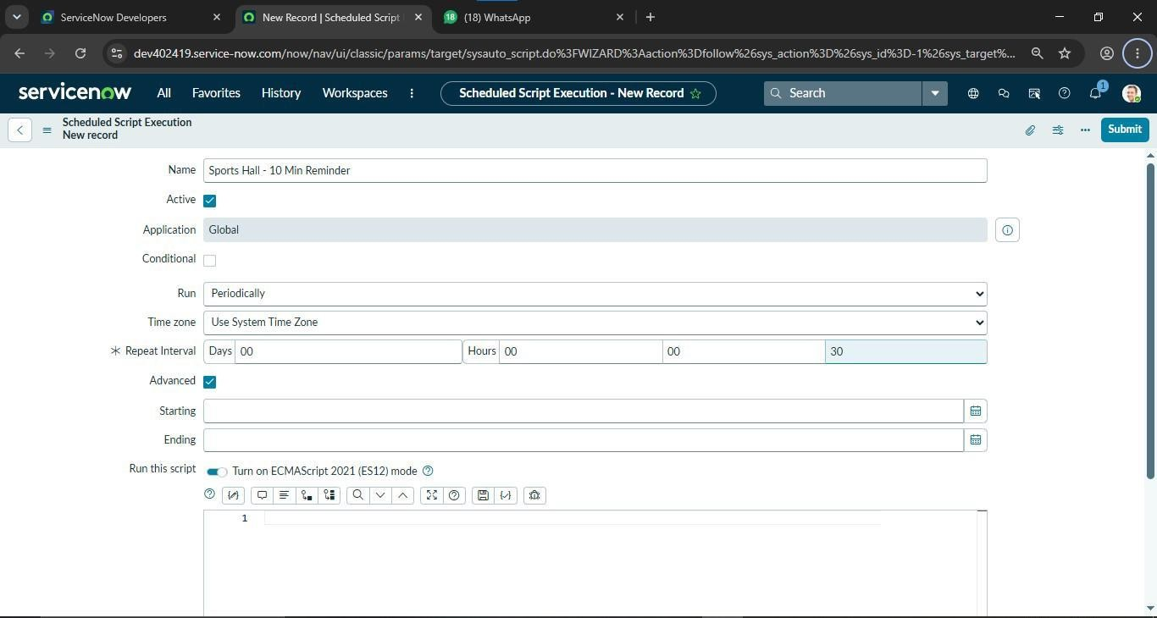

Activity 2. Configuring Scheduled Server Script
  - Write the Server Side Script in the Advanced Script Section as shown below
  - Write the Script as per our logic
  - Save the Server Script.
- Server Script for Auto Sending Email Reminders
(function() { // Get current datetime var now = new GlideDateTime();
// Calculate 5 minutes from now
var fiveMinutesLater = new GlideDateTime();
fiveMinutesLater.add(5 60 1000); // 5 minutes in milliseconds
// Calculate 7 minutes from now (window buffer)
var sevenMinutesLater = new GlideDateTime();
sevenMinutesLater.add(7 60 1000);
// Query bookings
var gr = new GlideRecord('u_sports_hall_bookings');
gr.addQuery('u_status', 'pending');
gr.addQuery('u_reminder_sent', false);
gr.addQuery('u_start_time', '>=', fiveMinutesLater.getValue());
gr.addQuery('u_start_time', '<=', sevenMinutesLater.getValue());
gr.query();
while (gr.next()) {
var startTime = gr.u_start_time.getDisplayValue();
var email = gr.u_email.toString();
var hallName = gr.u_hall_name.toString();
var bookedBy = gr.u_booked_by.getDisplayValue();
if (!email || email == '') {
gs.warn(' - Skipping: No email address');
continue;
}
// Send event to trigger notification
gs.eventQueue('sports.hall.reminder', gr, email, hallName);
// Update record
gr.u_reminder_sent = true;
gr.u_instructions = 'Reminder sent at ' + now.getDisplayValue();
gr.update();
}
})();
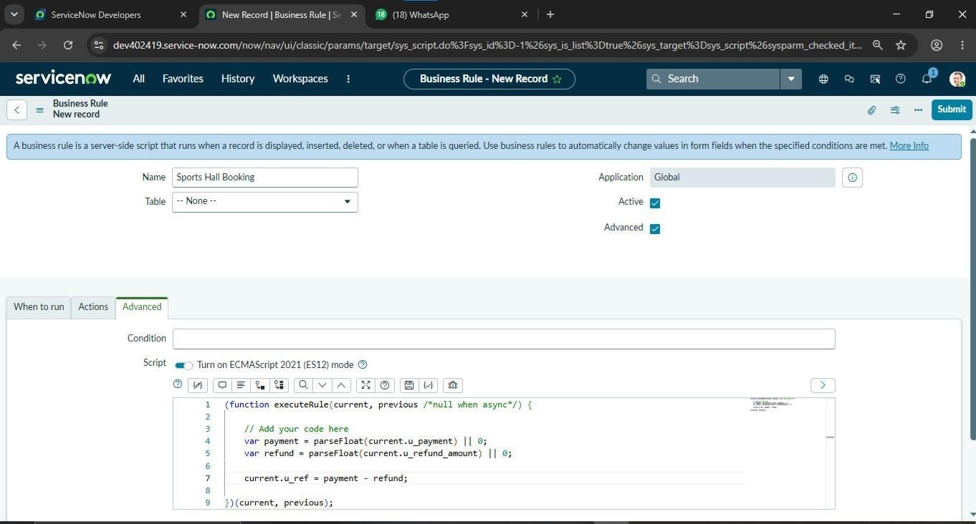
Business Rules

Creation & Implementation of Business Rules on Sports Bookings Hall Table

Activity 1. Navigation of Business Rules
- Navigate to All Menu
- Just type Business rules
- System definition >> Business Rules
- Click on New Button to Create a New Business Rules

MILESTON 3:UI/UX Development & Customization

Interface Design

Activity 1: Creation of Service Portal

- Navigate to the Application Navigator
- Click on All
- Search for Service Portal
- Under Service Portal, select Portals
- Click on New
- Fill in the portal details:
- Title: Sports Zone
- URL Suffix: sz
- Home Page: Select or create a new homepage(sports_booking)
- Theme: Default theme → La Jolla
- Click on Submit or Save
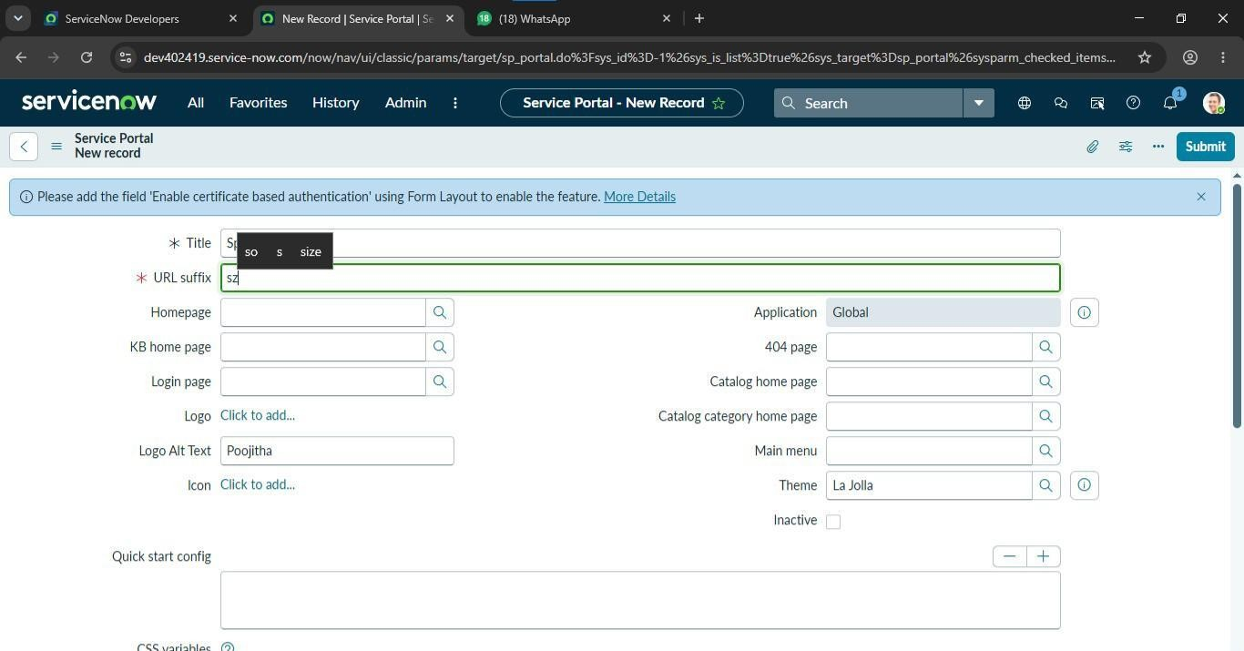

Activity 2: Home Logo Configuration

In the same Portal page we have CSS Variables section , Use the below CSS script to Design Home Page logo.

CSS Script:
.navbar-brand {
font-size: 30px !important;
font-weight: 700 !important;
letter-spacing: -1.5px !important;
color: #ffffff !important;
}
.navbar-brand .zone-text {
color: #00ff87 !important;
}

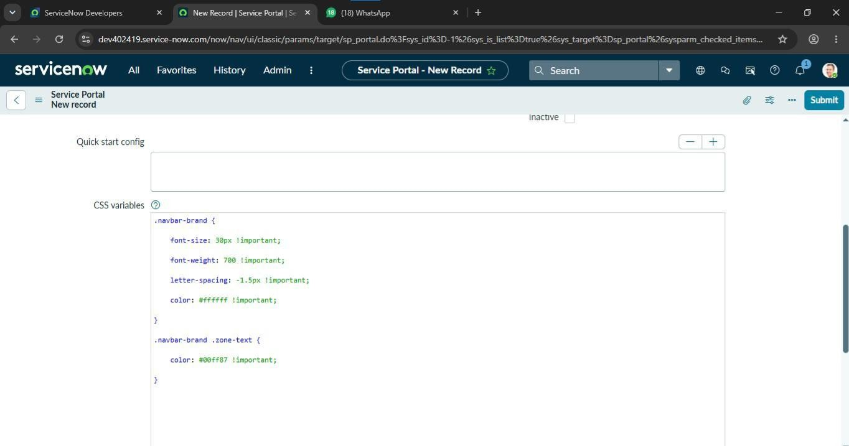
Navigation Flow

- Procedure:
- Login to ServiceNow PDI
- Copy the Instance domain ex: https://domain.service-now.com.
- Paste the URL in the Next tab and add Prefix SP to the URL,ex: https://dpamin.service-now.com/sz
- Select the Sport which you want book and click on proceed button
- You’ll navigate to payment page, make payment and click on Submit button
- Upon successful payments you will get a confirmation email with venue details.
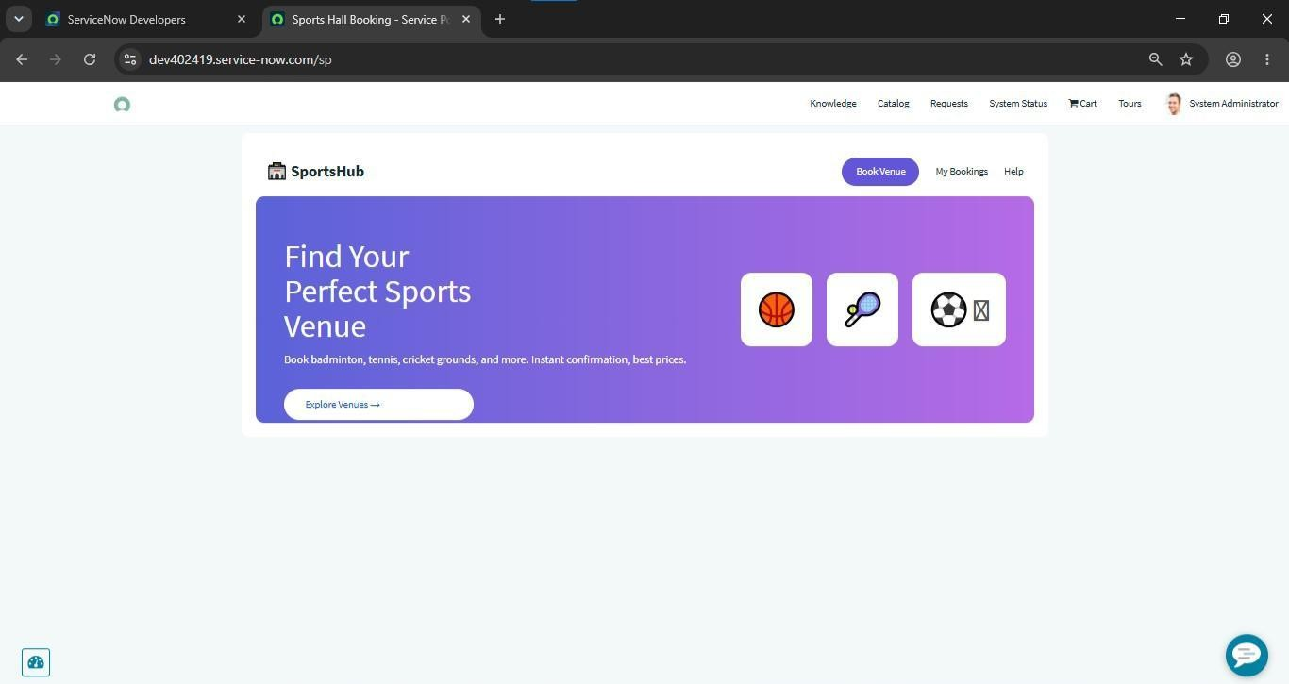

MILESTON 4:Data migration ,testing & security

Data handling

Activity 1: Configure Events:

- Navigate to the Application Navigator
- Click on All Search for Event Registry
- Under System Notification, select Events
- Click on New
- Fill in the event details:
- Name: sports.hall.reminder
- Table: u_sports_hall_bookings
- Fired By: Schedule Jobs
- Description: Event triggered when a Schedule jobs runs
- Click on Submit or Save

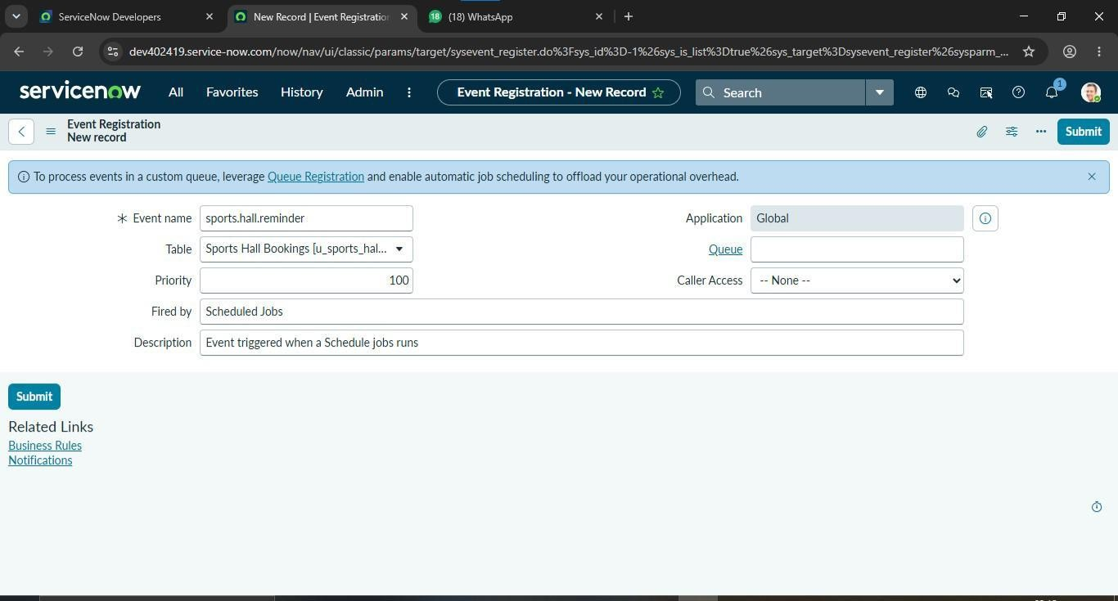
Activity 2: Configure Email Notifications:

- Navigate to the Application Navigator
- Click on All Search for System Notification
- Under System Notification, select Email > Notifications
- Click on New Fill in the notification details:
- Name: Booking confirmation reminder
- Table: u_sports_bookings_hall
- When to Send: Event is fired Event
- Name: sports.hall.reminder
- Active: True
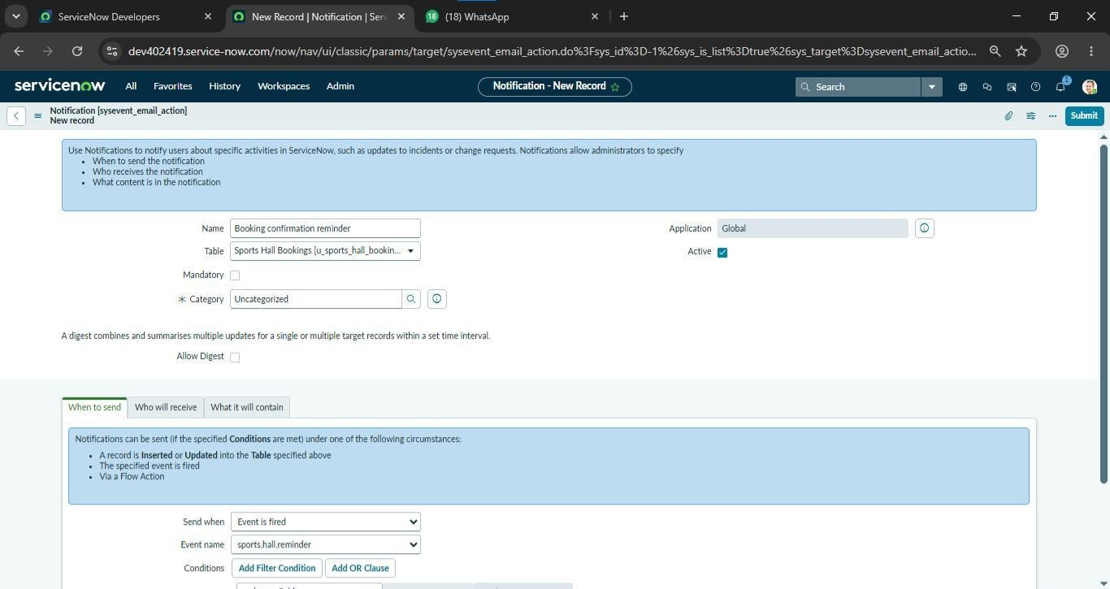

Project planning & Scheduling:
Assigned Task to the Group members as shown in below.

Functional  requirement | User story | No of  Activity | Team Members
Data  Architecture | As a developer, I want to design  the data architecture so that data is stored and managed efficiently. | 2 | Karri Lakshmi
Logics | As a developer, I want to  implement application logic so that the sports hall booking process works correctly. | 2 | Karri Lakshmi
Business  Rules | As an administrator, I want to  configure business rules so that booking operations are automated based on defined conditions. | 2 | Kaspa Manasa
Interface  Design 1 | As a user, I want an attractive  and user-friendly interface so that I can navigate the portal  easily | 2 | Kolaka pavani
Navigation Flow | As a user, I want a clear navigation flow so that I can  move between pages and | 2 | Kaspa Manasa
Data heading | As an administrator, I want to  manage and validate booking  data so that accurate  information is stored and  processed securely | 2 | Kolaka pavani
Business objectives | As a user, I want to book a sports hall through the Service Now portal so that I can easily reserve my preferred time slot and receive booking confirmation. | 2 | Karakavalasa kruparani
Functional Scope | As an administrator, I want to manage sports hall bookings through the ServiceNow platform so that users can easily book halls, administrators can manage reservations efficiently, and booking records are maintained accurately. | 2 | Karakavalasa kruparani
Stakeholder Mapping | As an administrator, I want to manage all stakeholders so that the Sports Hall Booking System operates efficiently and booking activities are well coordinated. | 2 | Kanda Yamini
Execution Roadmap | As a project administrator, I want to follow a structured execution roadmap so that the Sports Hall Booking System is developed efficiently and completed on schedule. | 2 | Kanda Yamini

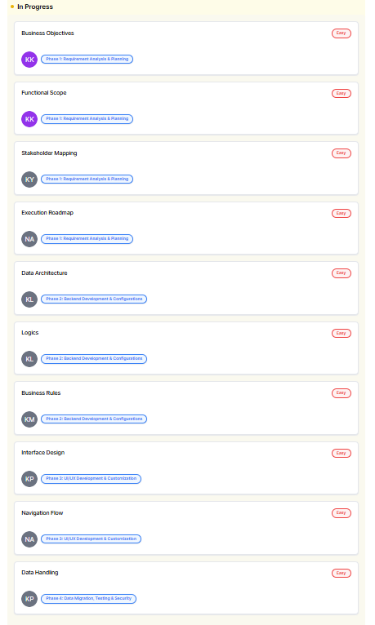

Functional and Performance Testing:

Functional Testing
Purpose: To verify that all features of the Sports Hall Booking System work correctly according to the requirements.

Testing Performed:
- User login works successfully.
- Sports hall booking is created correctly.
- Booking details are saved in the database.
- Booking status updates properly.
- Email notifications are sent after booking.
- Admin can view and manage all bookings.
- Invalid or incomplete form submissions display validation messages.
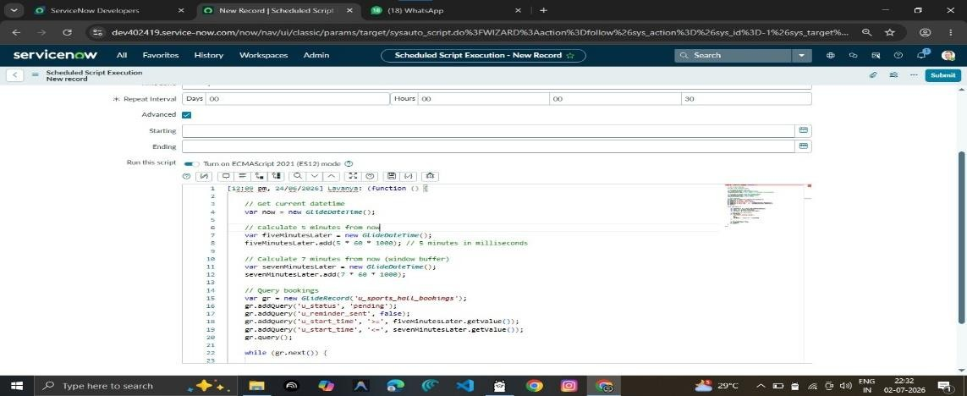
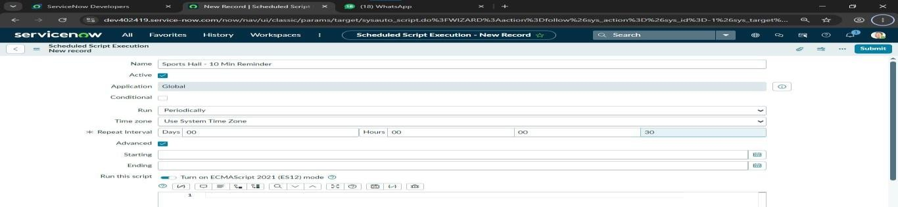
- Performance Testin

Performance Testing:
Purpose: To ensure the Sports Hall Booking System performs efficiently under normal usage.

Testing Performed:
- Booking pages load quickly.
- Multiple users can access the portal without significant delays.
- Booking records are retrieved efficiently.
- Email notifications are processed within an acceptable time.
- The system remains stable during continuous usage.

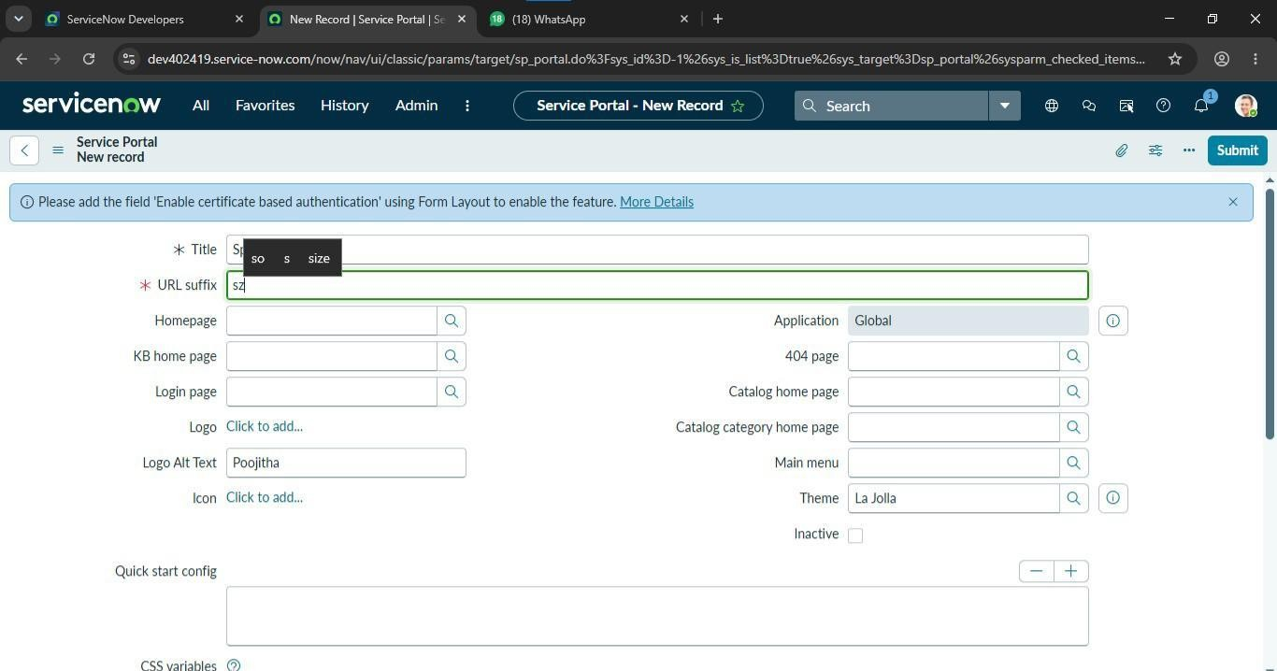
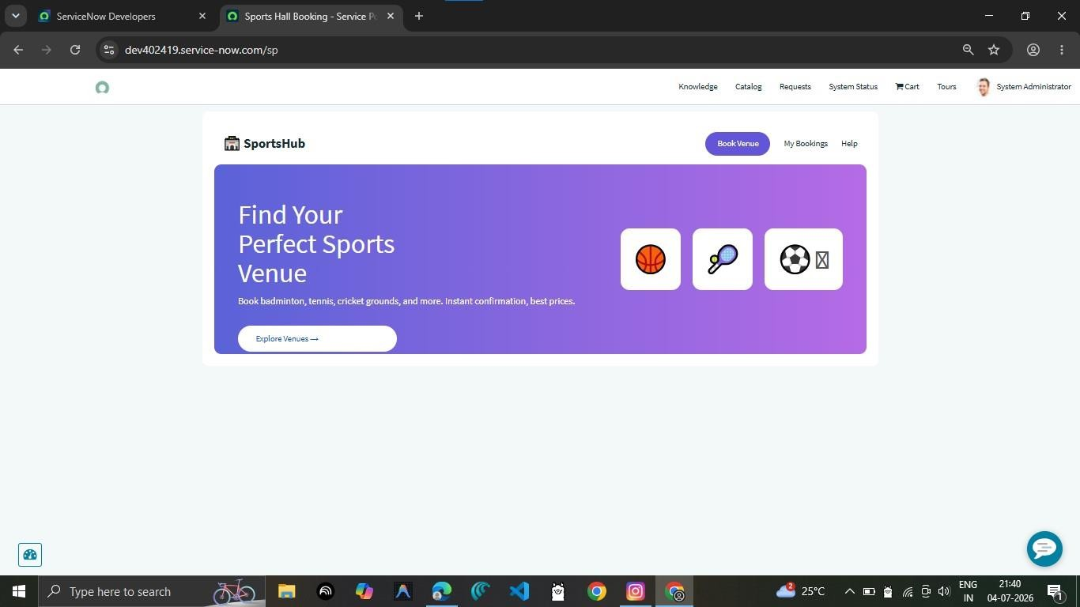

Advantages and Disadvantages:

ADVANTAGES:
- Centralized Booking Management: ServiceNow provides a unified platform to manage all sports hall bookings and schedules in one place.
- Automation & Workflow Integration: Automates booking requests, approvals, cancellations, and notifications using built-in workflows.
- Real-Time Availability: Displays live sports hall availability and booking status, preventing scheduling conflicts.
- Integration with ServiceNow Modules: Easily integrates with Service Portal, Notifications, Reports, and Flow Designer for seamless operations.
- User-Friendly Interface: Provides an intuitive and customizable interface for users and administrators.
- Scalable & Cloud-Based: Supports multiple sports facilities and users with secure cloud-based access.
- Security & Role-Based Access: Ensures secure booking management with role-based permissions for users and administrators.

DISADVANTAGES:

High Licensing Costs: ServiceNow is a premium platform, and implementing the booking system may require additional licensing costs.

Complex Setup & Customization: Initial configuration, workflows, and booking rules require technical expertise.

Training Required: Users and administrators may need training to use the system effectively.

Performance Depends on Configuration: Poorly designed workflows or excessive customization can impact system performance.

Ongoing Maintenance: Regular updates, testing, and system monitoring are required to ensure smooth operation and reliable booking services.

Conclusion:
The Sports Hall Booking System provides a comprehensive solution for managing and automating sports hall reservations through the ServiceNow platform. By leveraging workflow automation and real-time updates, the system ensures efficient booking management, minimizes scheduling conflicts, and improves the utilization of sports facilities. Automated approval workflows, notifications, and reporting enable administrators to manage bookings effectively while providing users with a simple and convenient booking experience.
The Sports Hall Booking System in ServiceNow offers a centralized, secure, and user-friendly solution for handling sports facility reservations. By utilizing ServiceNow's powerful features such as Service Portal, Flow Designer, Business Rules, Notifications, and Reports, the system streamlines the entire booking lifecycle—from request submission to approval, scheduling, and completion. Its seamless automation reduces manual effort, improves transparency, and enhances operational efficiency.
The project not only simplifies sports hall scheduling and facility management but also supports scalability, security, and better resource planning. Although the system requires initial configuration, licensing, and user training, its long-term benefits—including improved facility utilization, reduced administrative workload, enhanced user satisfaction, and data-driven decision-making—make it an effective solution for educational institutions and organizations. In conclusion, implementing the Sports Hall Booking System on the ServiceNow platform modernizes sports facility management and delivers an efficient, reliable, and digital booking experience.

